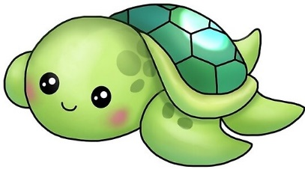
The Turtles
Daily Schedule

9:00-9:30am Free Play
9:30-9:40am Circle Time/Jesus Time*
9:40-10:00am Fine motor/Art
10:00-10:15am Diapers/Potty Break**
10:15-10:40am Wash hands/Snack Time
10:40-11:10am Outdoor Recess- Tot Lot
11:10-11:45am Wash hands/Lunch
11:45-12:25pm Art/Sensory bins/Music
12:25-12:45pm Diapers/Potty Break**
12:50-1:00pm Dismissal

*On inclement weather days, our indoor recess will be from 9:30-10:00 am.
*Children are NOT required to be potty trained in this class. Please let us know if they are independent with potty time and if so, when they usually “go” at home. We will try our best to continue with it at school, but, please understand we have 11 little ones and may not be able to stick to 11 different potty schedules at school.

